**Abstract**

*Deep learning approaches to medical image analysis have become very prevalent in the past decade, but still face many challenges that prevent its widespread adoption for applications as life-altering as diagnosis. Here, we present the results of using the VGG19 architecture on optical coherence tomography images of patients’ retinas to diagnose common retinal pathologies. We compare its performance with the performance of architectures used in past studies. We also visualize the saliency and class activation maps of the VGG19 to demonstrate that the predictions of the network are based on significant diagnostic features in the input retinal images. The tool that is developed in this study may ultimately expedite the diagnosis of treatable retinal conditions, leading to earlier treatment and more favorable clinical outcomes.*

# **Introduction**

Age-related macular degeneration (AMD) and diabetic macular edema (DME) are some of the leading causes of blindness worldwide. In the United States alone, almost 10 million individuals suffer from AMD [1]. Additionally, each year more than 200,000 people develop choroidal neovascularization (CNV) and nearly 750,000 individuals over the age of 40 suffer from DME [2]. Currently, anti-vascular endothelial growth factor (anti-VEGF) medications are used to treat such retinal diseases [3]. In order to administer these medications, optical coherence tomography (OCT) is needed to provide a clear cross-sectional representation of the retina. OCT uses light to capture high resolution cross sectional images of the retina, and is one of the most commonly performed medical imaging procedures worldwide. In fact, it is the only imaging modality that can resolve the cross-sections of the retina and can detect extracellular deposits known as drusens that are considered risk factors for AMD [4]. Thus, OCT is critical to the treatment of these diseases, though diagnosis through OCT can be slow and difficult using current methods [5]. The increasing demand of imaging studies has begun to quickly outpace the capacity of practicing radiologists, and more effective diagnostic tools are becoming necessary [6].

Some machine learning approaches have been traditionally used for medical image analysis, such as principal component analysis and support vector machines [7]. However, with the advent and success of deep learning and convolutional neural network (CNN) architectures in recent years, advanced techniques such as segmentation and highlighting important image features can be applied more effectively towards medical images. These deep learning models can be used as assistive diagnostic tools that can classify images as pathological or guide practitioners towards regions of interests, greatly enhancing clinical care.

Many types of deep learning architectures have been successfully implemented in the analysis of medical images and are still widely used, including AlexNet, VGG, and GoogLeNet/Inception [8]. They have been successfully used in applications such as lesion detection and volumetric analysis in mammography, chest radiography, and chest computed tomography [9]. Many studies have implemented these architectures within ophthalmology in detecting diabetic retinopathy from fundus photographs and segmentation of foveal vasculature [10][11].

This study expands the potential applications of deep learning in medical imaging by applying VGG19 and InceptionV3 architectures towards the analysis of OCT images. We used these retinal images as inputs to the model, which will then output a predicted retinal condition: CNV, DME, DRUSEN, or NORMAL. The goal is to create a tool that can expedite the diagnosis process of the aforementioned retinal pathologies and enhance clinical care of patients with these treatable conditions.

# **Related Work**

A previous study has investigated classifying three retinal pathologies from normal pathology - CNV, DME and drusens - using an InceptionV3 (IV3) architecture. IV3 is the third iteration of the GoogLeNet architecture that had high performance in the ImageNet Large Scale Visual Recognition Challenge in 2014. Further details of the architecture itself [12] and its use in the previous study [5] are discussed elsewhere but will be briefly described in Methods. The investigators achieved an accuracy of 96.6% on the test dataset and a diagnostic ability statistically similar to human experts within a 95% confidence interval. While this study demonstrated the IV3 architecture generalized well to chest x-ray images, IV3 is much deeper than VGG and can be less feasible to deploy in clinics with limited computational power. Thus, testing the performance of simpler architectures is advisable.

In comparing IV3 and VGG, the computational cost of using Inception was found to be much slower than VGGNet or its higher performing successors. With this inherently limited computational complexity, it has been made feasible to utilize Inception networks in big data scenarios [12]. The inception architecture of GoogLeNet however was found to add supervision at multiple internal layers of the network allowing us to connect task-specific “specialized” convolutional layers to the final layer of each stage [14].

The VGG architecture has been successfully applied in ophthalmology in recent studies. One study investigating segmentation of vessels in the retina uses the GoogLeNet idea of supervision in internal layers in a VGG architecture [14]. Another study applied a modified VGG16 to classify normal and AMD OCT images of the retina with about 2.6 million images and achieved an accuracy of 87.6% [7]. While these results are promising, only AMD is classified and such an accuracy is not competent enough for clinical implementation. Additionally, massive datasets of over one million medical images are not common. Based on all these previous studies, demonstrating the performance of a VGG architecture on a smaller dataset to classify more retinal conditions can expedite the adoption of CNNs in medical image analysis and diagnosis.

This study will adopt a VGG19 network for its simpler architecture, popular use in medical imaging, and previous applications in the segmentation of blood vessels and optic disk in retinas. The network architecture and configuration in Kermany et al. will also be trained on the same dataset as a benchmark for comparison to the approach detailed here.

# **Data**

*3.1 Dataset*

The images are provided in a dataset made publicly available by Kermany et al [5]. The dataset consists of 207,130 grayscale OCT images of the retinas of 4,686 patients. There are 37,206 images with CNV, 11,349 with DME, 8,617 with DRUSEN, and 51,140 that are normal. All images were verified by clinical experts that are trained to diagnose these diseases from OCT images. The dataset was split 80% - 66,813 images - for training and 20% - 16,703 images - for validation. Only 968 images were used for testing.

*3.2 Preprocessing*

Since the images were provided in various sizes, all images were resized to 256x256 pixels. These dimensions were chosen as the lowest common denominator across all the OCT images and to preserve a level of fidelity for the model to recognize small features in each retina. No other preprocessing steps were taken for this same reason.

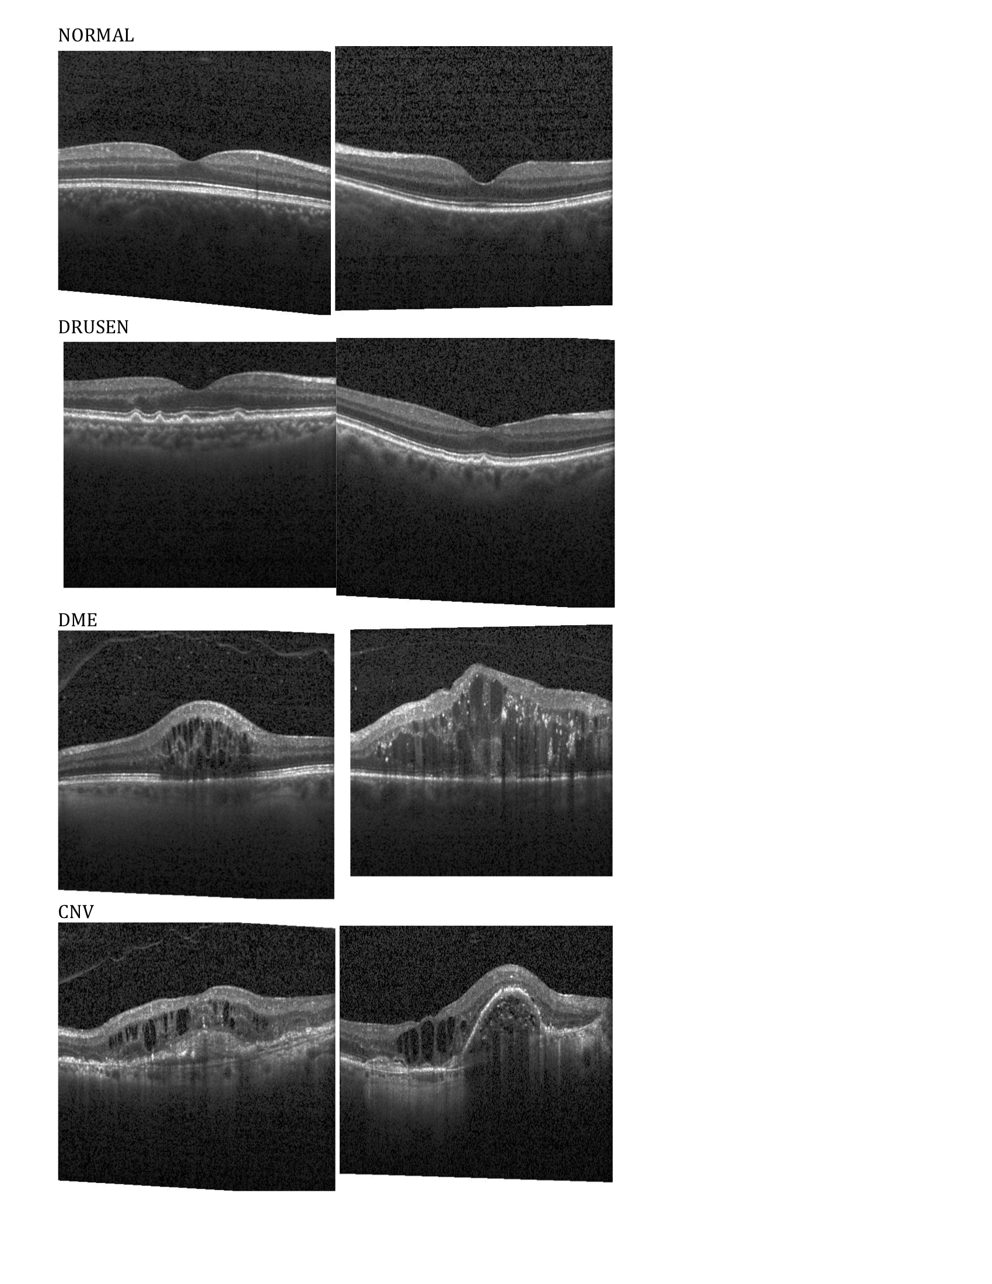

***Figure 1****: Sample resized retinal OCT images from each class used as inputs to the deep learning models.*

*3.3 Data Augmentation*

Data augmentation involves applying computationally inexpensive transformations to training images to artificially inflate the dataset. It has been shown to improve network performance by reducing overfitting. The motivation is to train the CNN model to become invariant to changes in position and orientation [15][16].

Many of the OCT images in the provided dataset are at different orientations. The fovea - the anatomical region that should contain the most distinguishing features for each class - is also found at various locations in the images. Additionally, the position and orientation may be further altered once the images are resized. Thus, data augmentation was implemented to prevent oversensitivity to geometric transformations and expand the training and validation datasets. Specifically, images were randomly flipped horizontally, zoomed, rotated, and shifted horizontally and vertically.

*3.4 Model Evaluation*

The past study was able to successfully implement an InceptionV3 architecture that achieved accuracies of 96.6%, so achieving similar accuracies or higher is expected. Our architecture will be evaluated by comparing its performance to the performance described in the past study and by comparing both architectures’ saliency and class activation maps.

# **Methods**

*4.1 AlexNet*

Before training a VGGnet, our first approach was to create an AlexNet from scratch to determine if it can correctly classify the four categories. Our intuition was that the simplicity of the grayscale OCT images should allow the AlexNet to quickly achieve high accuracies. Additionally, since it was deployed previous in the analysis of medical images, an initial attempt with this architecture was warranted. While training accuracies initially were very high, validation accuracies remained low, indicating clear overfitting. The training dataset was also relatively small compared to most datasets convolutional neural networks are trained on. Thus, to address this issue, we decided that transfer learning was the optimal method to train our architectures.

*4.2 Transfer Learning*

Transfer learning involves training an architecture with weights that have been previously trained on a larger dataset. When the model sees the new dataset, only the top few layers or only the classifier is trained, which can drastically reduce training time, computational expenditures, and prevent overfitting. In computer vision, most architectures are already pre-trained on ImageNet, a massive database with over one million images, so the weights are considered to be reliable. We decided to load the VGG19 and InceptionV3 with weights pre-trained on ImageNet.

*4.3 VGG19 Architecture and Training*

The VGG19 was modified to be capable of learning new features from the images in our dataset. Specifically, the first five layers were fixed so that their parameters could not be trained. The top three fully connected layers were removed and replaced with custom layers: a fully connected layer with 1024 nodes, ReLU activation, and a dropout layer with keep probability of 50%; another fully connected layer with 1024 nodes; and a final fully connected layers with four nodes and softmax activation.

ReLU activation is a common activation function used in convolutional and fully connected layers. It is computationally inexpensive and can greatly accelerate convergence of stochastic gradient descent due to its linear, non-saturating form [17]. The equation is given in (1).



Dropout is the process of keeping a neuron’s activation with certain probability or setting its output to zero. This essentially allows subsampling of the entire network during training, preventing cohabitation of the neurons in the network. This regularization method is further described in [18].

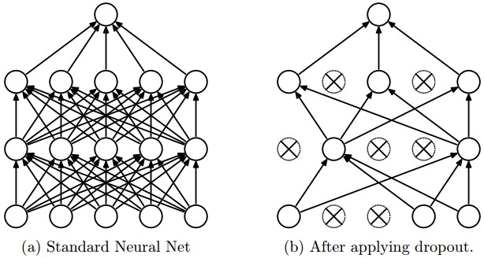

***Figure 2:*** *Illustration of dropout regularization, adapted from [18].*

Softmax activation is typically used for classification applications. This is because the output is bounded between 0 and 1 and can serve as the probability that an input belongs to a certain category. The equation is described in (2).

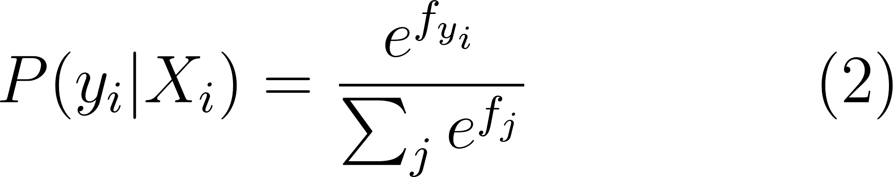

The softmax function outputs the probability  that a given input  belongs to class , with 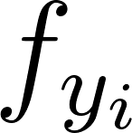representing the unnormalized score of the correct class and 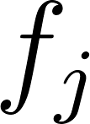 representing unnormalized score for class .

The output of the final custom layer served as the model’s final class prediction. Since our application involves significantly fewer but similar classes compared to ImageNet, we reduced the number of nodes in the fully connected layers to prevent overfitting. The weights in these layers were initialized based on Xavier initialization [19], in which they are randomly sampled from a distribution of zero mean and variance as detailed in (3).

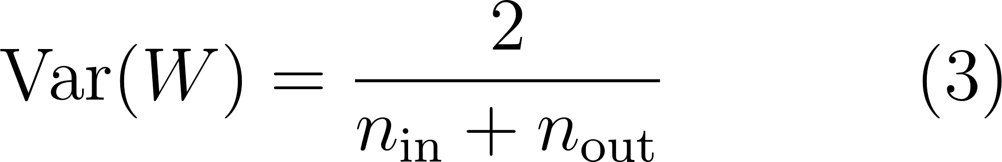

Since the class labels are one-hot encoded vectors, the cross-entropy loss was used as the objective function to minimize, described in (4) using the softmax probabilities from (2).

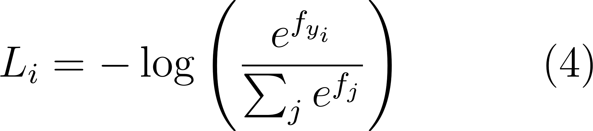

Learning was performed using stochastic gradient descent (SGD) with a batch size of 128 images, learning rate of 10-3, and momentum of 0.9. The SGD with momentum algorithm is detailed in (5).





The gradient of the loss is calculated using one example with respect to the parameters that are being updated. In vanilla SGD, the gradient is scaled by learning rate  and subtracted from the parameters for the update. However, here a velocity term is added with a momentum term, 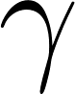. This is subtracted from  instead for the update. Adding momentum to SGD essentially allows parameters to update faster in directions of consistent gradients and almost always converges faster.

Batch size was optimized by minimizing time required for single epoch completion based on available GPUs while maintaining the smallest possible batches. Since this learning algorithm served the VGG architecture well on ImageNet, we decided to apply it in our application as well. The model was set to stop training once validation accuracy stop improving after ten consecutive epochs, resulting in 31 epochs of training. Each epoch consisted of 521 steps through the dataset, where each step is a single batch. Thus, the VGG model was trained for 16,151 steps.

*4.4 InceptionV3 Architecture and Training*

To provide a benchmark for comparison, an InceptionV3 architecture was also trained on the same dataset, the configuration and training of which is described in Kermany et al. Briefly, the weights of the IV3 net were pre-trained on ImageNet and remained fixed. Only the final softmax layer was trained from scratch to recognize the four classes. The model was trained with stochastic gradient descent using an Adam Optimizer on batches of 1000 images. The Adam optimization algorithm is further detailed in [20], but briefly summarized in Figure 3. Unlike SGD with momentum updates, Adam adaptively tunes learning rate per parameter and enjoys efficient convergence.

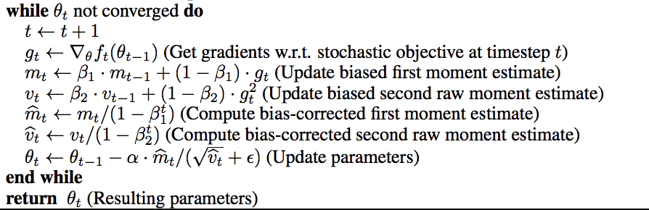

***Figure 3:*** *Algorithm for Adam Optimizer with bias correction, adapted from [20].*

The same loss function was used for IV3. The model also happened to train for 31 epochs and stopped because the validation accuracy failed to improve for ten consecutive epochs. Each epoch consisted of 66 steps due to a much larger batch size. The IV3 model was thus trained for 2,046 steps.

*4.5 Network Visualization*

Network visualization involves using certain mathematical tools to determine what features each convolutional layer is examining, which pixels in the images contribute most to minimizing loss for that class, and many other aspects to understand the “black box” of all the layers in convolutional neural networks. Two visualization methods we employ are saliency maps and class activation maps.

Saliency maps are representations of the image where the intensity of each pixel represents its influence on the class score [21]. Further details are discussed in the reference, but are briefly discussed here. This is determined by calculating the gradient during backpropagation of the class score with respect to each pixel in the image. Intuitively, this gradient contains information about how much a pixel in an image can contribute to the class score. Typically, the maximum gradient value across all three color channels is taken, but since the images in our dataset are grayscale, we simply take the absolute value of the gradient. By recoloring the image based on this gradient, we can determine which features are most relevant to determining each class.

Class activation maps are heatmaps that highlight discriminative image regions that the CNN used for that category [22]. This involves applying global average pooling after the final convolutional layer in a CNN architecture and using those features in a final fully connected layer to determine class scores. This will project back the weights of the output layer onto the convolutional feature maps, allowing the importance of certain image regions to be visualized. The process is described in more detail in [22], but essentially equation (6) produces the class activation maps , where  and  are the position of a pixel, 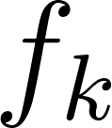 is the activation of node  in the last convolutional layer, and  is the weight corresponding to class  and node .

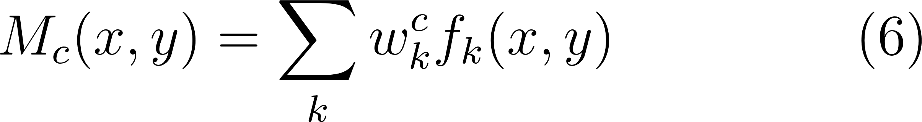

*4.6 Computational Infrastructure*

Models were trained on a Google Cloud instance on 8 CPUs, 8 NVIDIA Tesla K80 GPUs, and 29 GB of memory.

*4.7 Software*

All models were implemented using Keras API with a Tensorflow backend [23][24]. Graphs, saliency maps, and class activation maps were plotted using Matplotlib [25]. Visualization was done using third-party open-source toolkit keras-vis [26]. Other libraries that were utilized include NumPy [27], scikit-image [28], and OpenCV [29] for image loading.

1. **Results**

*5.1 Training*

The training performances of both models and their respective losses are shown in Figure 4. We noticed similar behavior in the training accuracy for both VGG and IV3, which is strange since both models used different optimization algorithms (Adam vs. SGD). Remarkably, InceptionV3 consistently performed worse than VGG by almost 20% in training accuracy and 40% in validation accuracy, despite its touted ability to capture finer features within the images. As seen in Figure 5, the IV3 model seemed to misclassify many of the DME and DRUSEN images. DRUSEN images are very similar to NORMAL images, though the classifier predicted many of the other conditions instead. Additionally, DME images are starkly different from most of the other classes. These misclassifications indicate that the model is not picking up important features in the images and could have been trained incorrectly. More diagnostics are needed to uncover the true flaws. A potential issue could have been the optimization algorithm itself; perhaps it was not training very efficiently with Adam or the batch sizes were too large, resulting in high training error and even higher 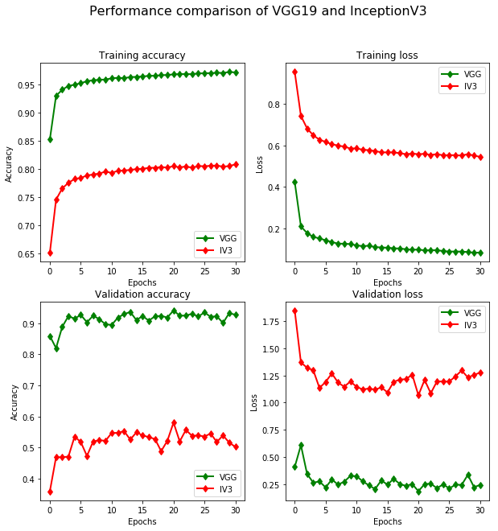***Figure 4:*** *Comparison of the VGG19 and InceptionV3 training and validation accuracies and losses.*

validation error. However, these parameters are the exact same as the parameters used in the study by Kermany et al., and they have achieved much higher accuracies.

Even though the models were trained for 31 epochs, validation accuracy and loss did not significantly improve after about five epochs for both models with marginal improvements in training accuracy and loss. Possible culprits could be too small a learning rate, too small a batch size, or need for Nesterov momentum. However, validation accuracy for VGG stabilized at a very high rate regardless, so we were comfortable moving on to the test dataset with the VGG model.

*5.2 Testing*

Both the VGG model and IV3 models made predictions on the test dataset. The performances on the test dataset are depicted in Figure 7 in comparison to the reported results in Kermany et al. The VGG model achieved about 98.6% accuracy on the test dataset, surpassing the accuracy achieved by the previous IV3 model and our current IV3 model. Considering any class other than normal as positive for a retinal disease, the VGG model’s precision was 100% and recall was 99.8%, and the IV3 model’s precision was 95.4% and recall was 90.9%. We speculate the reason for better performance is that for this application the Inception architecture may be too deep; the grayscale images of the retina do not contain nearly enough distinguishing features as ImageNet images that the classifier must learn to recognize. Additionally, the typical images for each class do not significantly differ from each other bar certain small features in each image. Perhaps the IV3 models overfit the images due to a greater number of parameters than the VGG model, though the low training accuracy seems to contradict this notion.

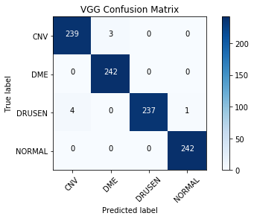*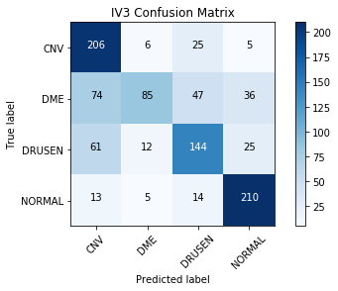****Figure 5:*** *Confusion matrices for both models. A darker blue indicates more images correctly classified. Precision and recall for VGG was 100% and 99.8%, respectively. Precision and recall for IV3 was 95.4% and 90.9%, respectively.*

*5.3 Visualization*

To investigate these performance differences further, we sought to visualize the features of the images in each class that both models are primarily focused on to assign their classifications. Figure 8 explores this by depicting the saliency maps of both models on a sample image from each class. Seemingly, the brow shape of the fovea in the center of the NORMAL image contributed most to its classification in the VGG model. This seems logical since this morphology is not prominent in the other classes. DRUSEN images tend to have this brow shape as well, though the saliency map shows that it plays less of a role than in the NORMAL image, but more so than in the other classes. What’s most interesting is that the drusens that are visible to the human eye in the DRUSEN image are indeed the most important features in the VGG saliency map, indicating that the model is extracting physiologically relevant features to determine classifications. Because the pathological features of the CNV and DME images are more widespread, no particular location is most bright in the VGG saliency map. Fortunately, the VGG model seems to capture the general pathological morphology of both conditions based on the saliency maps in Figure 8, though the most ideal scenario would have been highlights of the individual swellings of retinal fluid in DME and neovascular tissue in CNV. The saliency maps of the IV3 model show some general understanding of the features of the image, but they are more scattered than the maps of the VGG model. This may be a contributing factor to the low accuracy of the IV3 model.

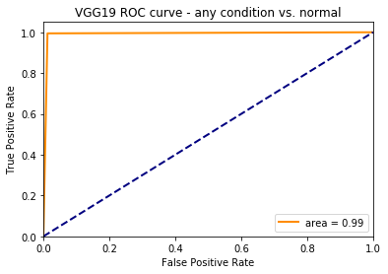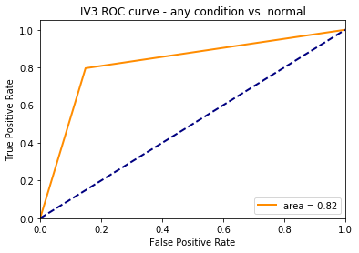

***Figure 6:*** *Receiver operating characteristic curves for each model where a true positive means the classifier detected an abnormal condition successfully. The area under the curve indicates the difference between performances of the two models.*

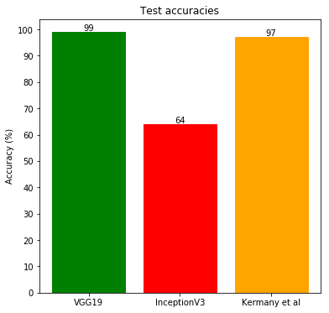

***Figure 7:*** *Comparison of performances of each model on the test dataset, rounded to the nearest percent.*

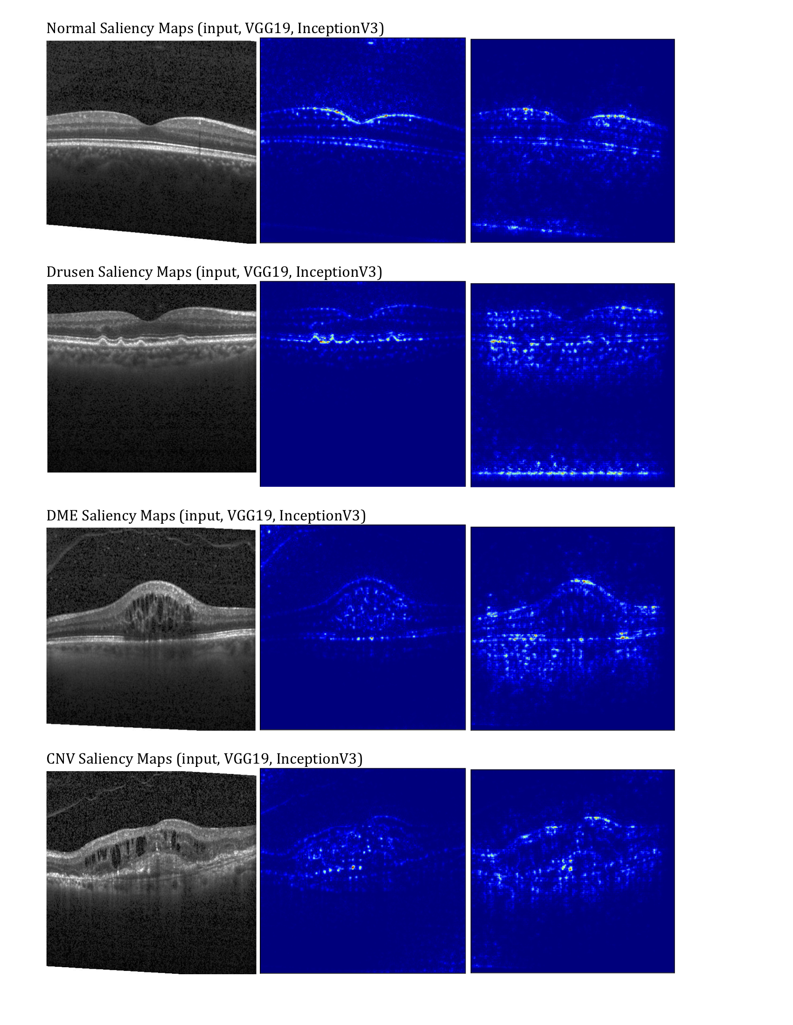

***Figure 8:*** *Saliency maps of both models indicating which pixels in each sample image contribute most to class score.*

Figure 9 indicates the IV3 model does not hone in on any relevant features of each image; the red areas of the heatmap indicating the regions of greatest contributions to the category are nowhere near the actual features of the image. An accuracy of 64% despite this flaw is remarkable, and perhaps with some modifications the IV3 architecture can achieve comparable performance. More promising are the class activation maps from the VGG model; the highlighted regions are typical pathological features that are used to diagnose the condition. In CNV, the red region highlights neovascular membrane, new blood vessels that are growing underneath the retina and are damaging tissue. In DME, the intraretinal fluid is being highlighted by the red region. In DRUSEN, three of the four visible drusens lie in the red regions. Naturally, the NORMAL image has the foveal area highlighted, since this area and the aforementioned brow shape is compromised in other retinal conditions. Based on these class activation and saliency maps, the stellar performance of the VGG19 is warranted and encouraging.

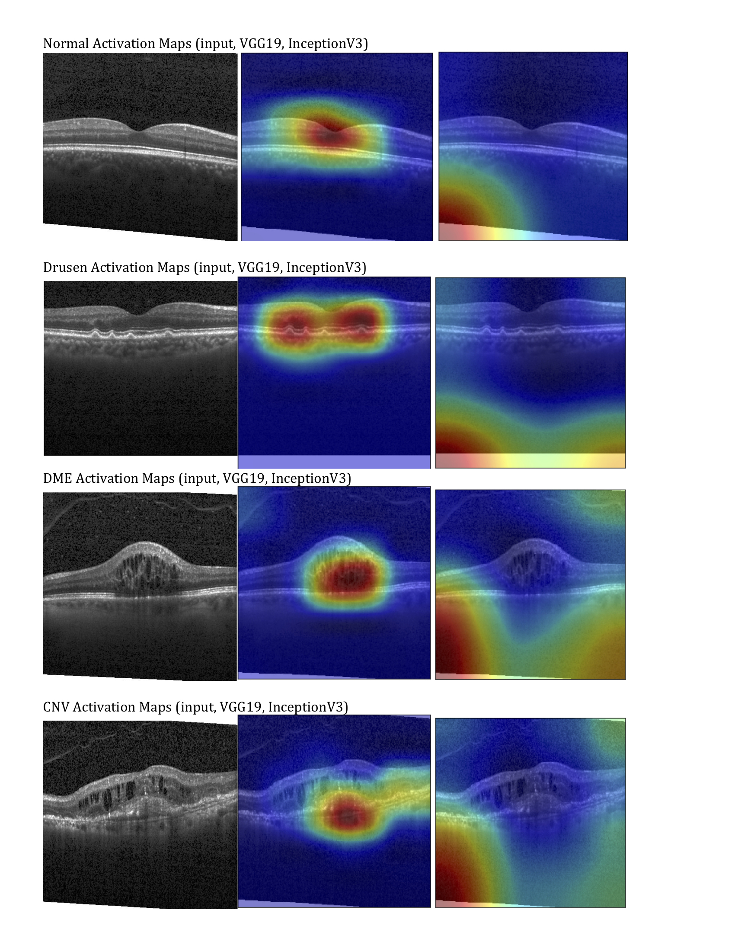

***Figure 9:*** *Class activation maps of both models indicating image regions CNN classifiers utilized to determine category.*

1. **Conclusion**

Pathology of the retina can become a debilitating condition if treatment is suboptimal. The number of individuals suffering from retinal conditions represents a dire need for better interventions and therapies for these patients. Deep learning approaches have enjoyed success in many fields, but demand pristine performance in medical imaging to improve the clinical outcomes of as many patients as possible. In ophthalmology, network architectures such as VGG, GoogLeNet, and AlexNet have been successfully employed to categorize disease and highlight regions of interest, but more work needs to be done. In this study, a VGG19 network and InceptionV3 network pretrained on ImageNet are deployed on a dataset of optical coherence tomography images of the retinas 4,686 patients using transfer learning. We found that the VGG architecture achieved an accuracy of 98.6%, outclassing our implementation of IV3 and the accuracies reported by similar architectures in past studies. By visualizing the saliency and class activation maps of each model, we determined that the VGG network was able to successfully discriminate pathophysiological features of each condition to determine classification, while the IV3 model was more scattered. The performance and visualization of our implementation of IV3 does not match the reported results in the past study Kermany et al., indicating potential issues with training or presence of a more optimal configuration. Regardless, with the stellar performance of the VGG19 model, we hope that such an architecture can be successfully utilized in clinics to diagnose retinal diseases. Deep learning approaches are becoming increasingly efficient and are almost close to outperforming trained practitioners. These results show promise in expediting medical procedures using deep learning, leading to more favorable clinical outcomes.

1. **Future Work**

While the performances reported here are promising, much work is left to be done. The training dataset in this study is relatively small compared to most datasets in computer vision. Before employing the model in clinical usage, one would need to train and test on a much larger dataset. Additionally, one could attempt to build a VGG or IV3 model trained entirely on a massive OCT dataset with fresh weights in order to discern whether transfer learning, the less expensive and time consuming option, classifies just as efficiently. Furthermore, the VGG model’s performance needs to be compared to the performance of a human practitioner. This will inform clinics whether the “black box” that is machine learning can be trusted to assist them with actual patients.

Diagnosing retinal conditions using OCT images is a very niche role for a complex and computationally expensive algorithm. Demonstrating the generalizability of the VGG model is thus necessary to determine its robustness. Kermany et al. investigated the generalizability of their IV3 model with chest x-ray images and was successful. A similar approach could be taken with VGG on other grayscale medical images of soft tissue, such as structural MRI images of the brain. This could be especially necessary in fields lacking a large enough dataset, where transfer learning could be successfully applied.

The InceptionV3 architecture has proven to be more efficient than comparable models in past studies, so investigating the lack of performance in this study would be wise. More visualization tools and tests are needed to determine whether the network is overfitting or not optimizing correctly.

1. **Contributions & Acknowledgements**

Dataset of high-resolution OCT images can be found in the public Mendeley database (<https://doi.org/10.17632/rscbjbr9sj.3>). Code largely adapted from [30] but modified for parallelization and use with InceptionV3. Visualization was performed with helper functions from keras-vis [26].

Paper was written by both Ayub and Sikder. Poster was created by Sikder. Implementation of models was done in Jupyter Notebook and Google Cloud by Ayub.

# **References**

1. Friedman, D.S., O’Colmain, B.J., Mun˜ oz, B., Tomany, S.C., McCarty, C., de Jong, P.T., Nemesure, B., Mitchell, P., and Kempen, J.; Eye Diseases Prevalence Research Group (2004). Prevalence of age-related macular degeneration in the United States. Arch. Ophthalmol. 122, 564–572.
2. Wong, W.L., Su, X., Li, X., Cheung, C.M., Klein, R., Cheng, C.Y., and Wong, T.Y. (2014). Global prevalence of age-related macular degeneration and disease burden projection for 2020 and 2040: a systematic review and meta-analysis. Lancet Glob. Health 2, e106–e116.
3. Ferrara, N. (2010). Vascular endothelial growth factor and age-related macular degeneration: from basic science to therapy. Nat. Med. 16, 1107–1111.
4. Schuman, S. G., Koreishi, A. F., Farsiu, S., Jung, S., Izatt, J. a, & Toth, C. a. (2009). Photoreceptor Layer Thinning over Drusen in Eyes with Age-Related Macular Degeneration Imaged In Vivo with Spectral-Domain Optical Coherence Tomography. *Ophthalmology*, *116*(3), 488–496.e2. https://doi.org/10.1016/j.ophtha.2008.10.006
5. Kermany, D. S., Goldbaum, M., Cai, W., Valentim, C. C., Liang, H., Baxter, S. L., … Zhang, K. (2018). Identifying Medical Diagnoses and Treatable Diseases by Image-Based Deep Learning. *Cell*, *172*(5), 1122-1131.e9.
6. Smieliauskas F, MacMahon H, Salgia R, Shih Y-CT. Geographic variation in radiologist capacity and widespread implementation of lung cancer CT screening. J Med Screen. 2014;21:207e215.  
   11.
7. Lee, C. S., Baughman, D. M., & Lee, A. Y. (2017). Deep Learning Is Effective for Classifying Normal versus Age-Related Macular Degeneration OCT Images. *Ophthalmology Retina*, *1*(4), 322–327. https://doi.org/10.1016/j.oret.2016.12.009
8. Litjens, G., Kooi, T., Bejnordi, B. E., Setio, A. A. A., Ciompi, F., Ghafoorian, M., … Sánchez, C. I. (2017). A survey on deep learning in medical image analysis. *Medical Image Analysis*, *42*(1995), 60–88. <https://doi.org/10.1016/j.media.2017.07.005>
9. Van Ginneken B, Schaefer-Prokop CM, Prokop M. Computer- aided diagnosis: how to move from the laboratory to the clinic. Radiology. 2011;261:719e732.
10. Abràmoff MD, Lou Y, Erginay A, et al. Improved automated detection of diabetic retinopathy on a publicly available dataset through integration of deep learning. Invest Ophthalmol Vis Sci. 2016;57:5200e5206.
11. Prenta sic P, Heisler M, Mammo Z, et al. Segmentation of the foveal microvasculature using deep learning networks. J Biomed Opt. 2016;21:075008.
12. Szegedy, C., Vanhoucke, V., Ioffe, S., Shlens, J., & Wojna, Z. (2016). Rethinking the Inception Architecture for Computer Vision. In *2016 IEEE Conference on Computer Vision and Pattern Recognition (CVPR)* (pp. 2818–2826). IEEE. https://doi.org/10.1109/CVPR.2016.308
13. Simonyan, K., & Zisserman, A. (2014). Very Deep Convolutional Networks for Large-Scale Image Recognition. *Information and Software Technology*, *51*(4), 769–784. https://doi.org/10.1016/j.infsof.2008.09.005
14. Maninis, K.-K., Pont-Tuset, J., Arbeláez, P., & Van Gool, L. (2016). Deep Retinal Image Understanding (pp. 140–148). https://doi.org/10.1007/978-3-319-46723-8_17
15. Wang J, Perez L. The effectiveness of data augmentation in image classification using deep learning. Technical report. 2017.
16. Taylor, L., & Nitschke, G. (2017). Improving Deep Learning using Generic Data Augmentation. Retrieved from <http://arxiv.org/abs/1708.06020>
17. Krizhevsky, A., Sutskever, I., & Geoffrey E., H. (2012). ImageNet Classification with Deep Convolutional Neural Networks. *Advances in Neural Information Processing Systems 25 (NIPS2012)*, 1–9. <https://doi.org/10.1109/5.726791>
18. Srivastava, N., Hinton, G., Krizhevsky, A., Sutskever, I., & Salakhutdinov, R. (2014). Dropout: A Simple Way to Prevent Neural Networks from Overfitting. *Journal of Machine Learning Research*, *15*, 1929–1958. <https://doi.org/10.1214/12-AOS1000>
19. Glorot, X., & Bengio, Y. (2010). Understanding the difficulty of training deep feedforward neural networks. *Pmlr*, *9*, 249–256. <https://doi.org/10.1.1.207.2059>
20. Kingma, D. P., & Ba, J. (2014). Adam: A Method for Stochastic Optimization, 1–15. https://doi.org/http://doi.acm.org.ezproxy.lib.ucf.edu/10.1145/1830483.1830503
21. Simonyan, K., Vedaldi, A., & Zisserman, A. (2013). Deep Inside Convolutional Networks: Visualising Image Classification Models and Saliency Maps, 1–8. Retrieved from http://arxiv.org/abs/1312.6034
22. Zhou, B., Khosla, A., Lapedriza, A., Oliva, A., & Torralba, A. (2015). Learning Deep Features for Discriminative Localization, 2921–2929. <https://doi.org/10.1109/CVPR.2016.319>
23. Chollet, François. (2015). keras. GitHub repository. <https://github.com/fchollet/keras>
24. Abadi, M., Barham, P., Chen, J., Chen, Z., Davis, A., Dean, J., … Brain, G. (2016). TensorFlow: A System for Large-Scale Machine Learning TensorFlow: A system for large-scale machine learning. *12th USENIX Symposium on Operating Systems Design and Implementation (OSDI ’16)*, 265–284. https://doi.org/10.1038/nn.3331
25. Hunter, J. D. (2007). Matplotlib: A 2D graphics environment. *Computing in Science and Engineering*, *9*(3), 99–104. https://doi.org/10.1109/MCSE.2007.55
26. Kotikalapudi, Raghavendra et al. (2017). keras-vis. GitHub repository. <https://github.com/raghakot/keras-vis>
27. Travis E, Oliphant. A guide to NumPy, USA: Trelgol Publishing, (2006).
28. Stéfan van der Walt, Johannes L. Schönberger, Juan Nunez-Iglesias, François Boulogne, Joshua D. Warner, Neil Yager, Emmanuelle Gouillart, Tony Yu and the scikit-image contributors. scikit-image: Image processing in Python, PeerJ 2:e453 (2014).
29. Bradski, G. (2000). The OpenCV Library. Dr. Dobb's Journal of Software Tools.
30. Vanapalli, Prakash. <https://gist.github.com/Prakashvanapalli/221571cf036179ed5343432eca16e72b#file-transfer_learning_keras_01-py>